**Overview**

The IIS-With-Bindings AnyAgent allows a user to create, configure, and manage a Keyfactor certificate store defined as an Internet Information Systems (IIS) binding definition. The certificate itself will still be stored in the defined server’s personal certificate store, but the management within Keyfactor will be abstracted to appear as if the binding itself houses the certificate.

During Keyfactor Command certificate store setup, the store path will need to contain the IIS binding information in WebSiteName/IPAddress/PortNumber/HostName format. The first 3 nodes are required. HostName is optional and can be left off if no host name is needed for the IIS binding.

This agent implements three job types – Inventory, Management Add, and Management Remove. Below are the steps necessary to configure this AnyAgent.

**1. Create the New Certificate Store Type for the New IIS-With-Bindings AnyAgent**

In Keyfactor Command create a new Certificate Store Type similar to the one below:

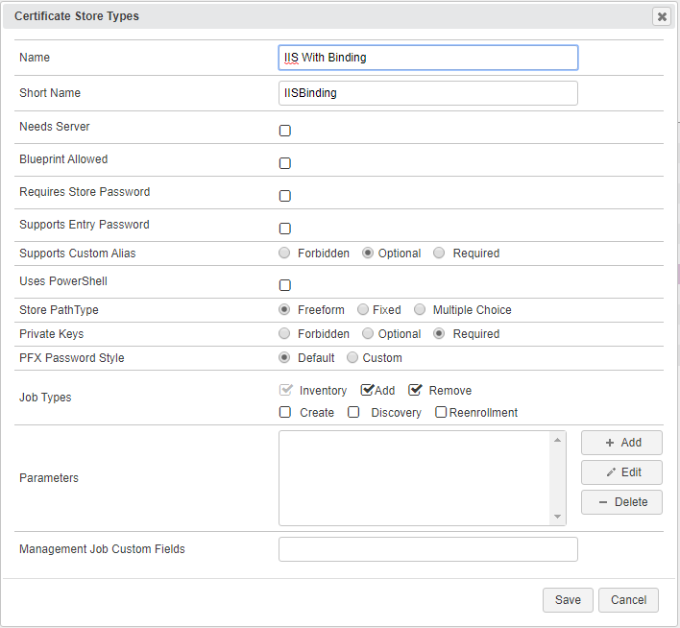

* **Name** – Required. The display name of the new Certificate Store Type
* **Short Name** – Required. **MUST** be “IISBinding”
* **Needs Server, Blueprint Allowed, Requires Store Password, Supports Entry Password** – unchecked
* **Supports Custom Alias** – Not applicable, so “Optional” is fine
* **Use PowerShell** – Unchecked
* **Store PathType** – Freeform (user will enter the web site IIS binding information here)
* **Private Keys** – Required (the private key must be delivered to the certificate store for IIS binding)
* **PFX Password Style** – Default
* **Job Types** – Inventory, Add, and Remove are the 3 job types implemented by this AnyAgent

**2. Register the IIS-With-Bindings AnyAgent with Keyfactor**

Open the Keyfactor Windows Agent Configuration Wizard and perform the tasks as illustrated below:

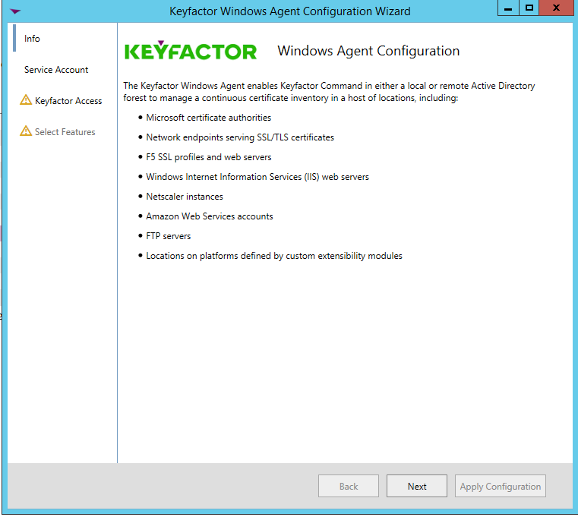

* Click **<Next>**

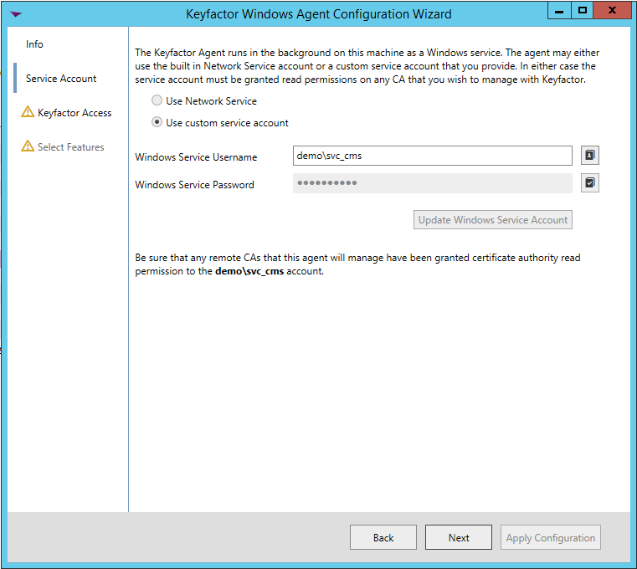

* If you have configured the agent service previously, you should be able to skip to just click **<Next>.** Otherwise, enter the service account Username and Password you wish to run the Keyfactor Windows Agent Service under, click **<Update Windows Service Account>** and click **<Next>.**

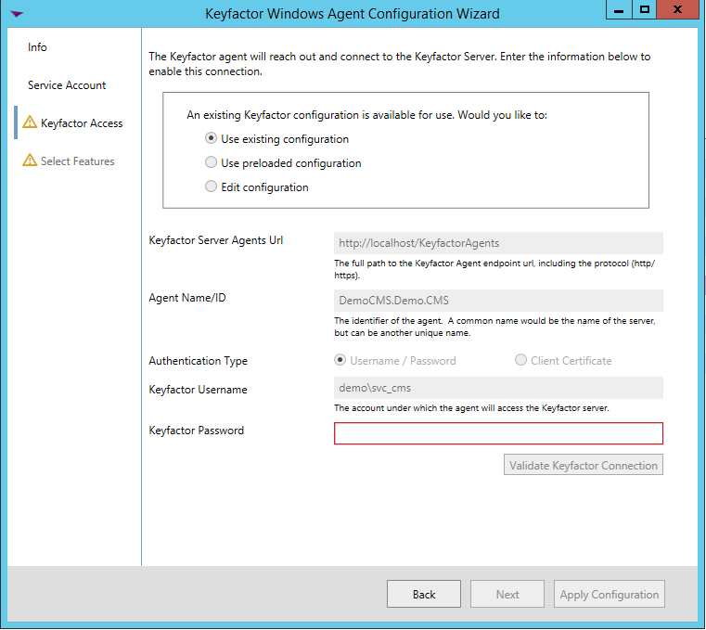

* If you have configured the agent service previously, you should be able to skip to just re-enter the password to the service account the agent service will run under, click **<Validate Keyfactor Connection>** and then **<Next>.**

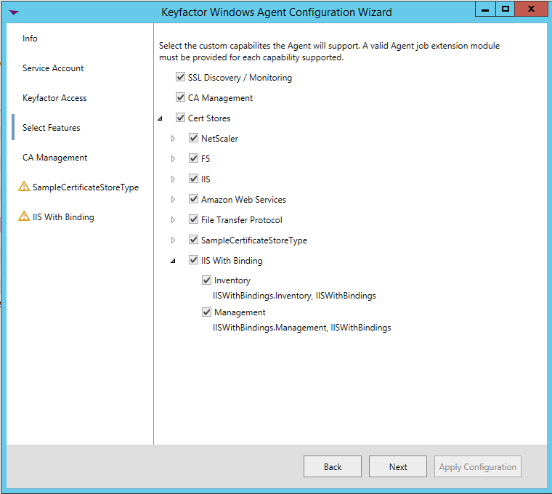

* Select the agent you are adding capabilities for (in this case, IIS With Binding, and also select the specific capabilities (Inventory and Management in this example). Click **<Next>**.

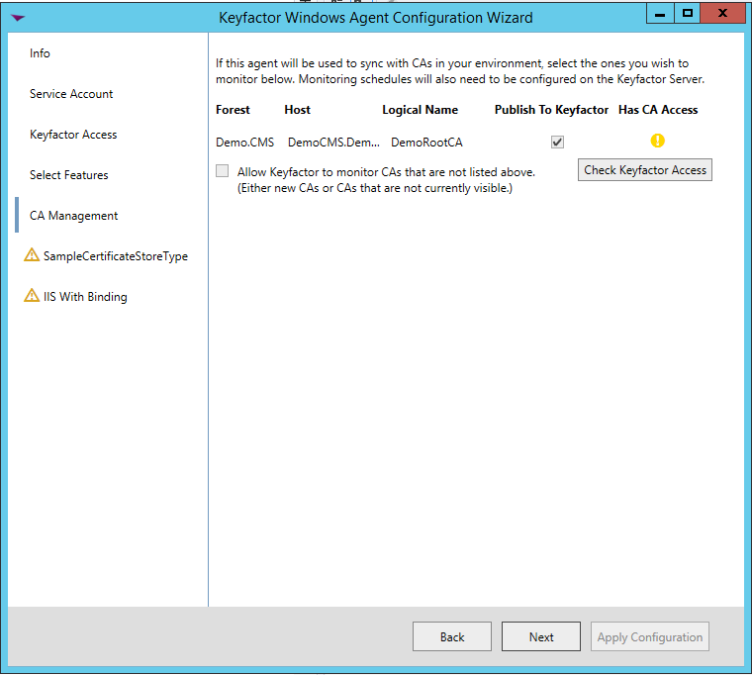

* For agent configuration purposes, this screen can be skipped by clicking **<Next>**.

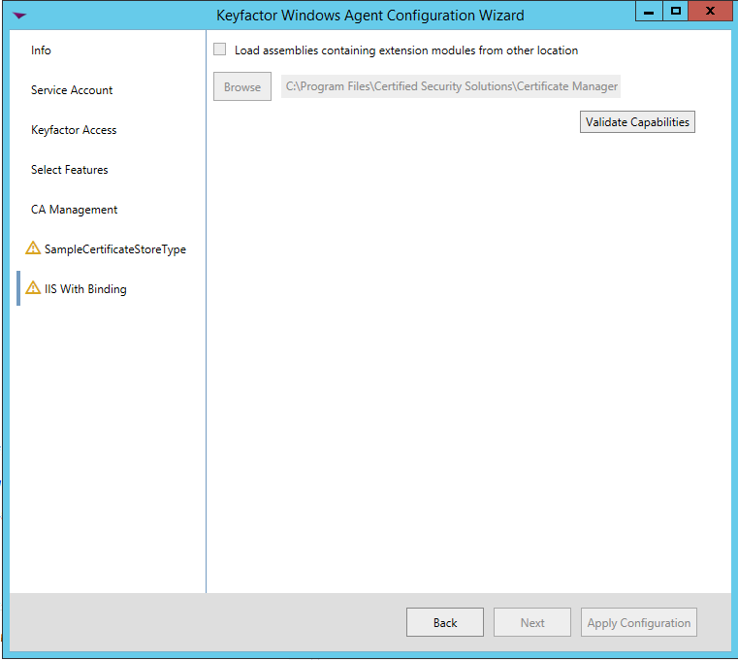

* For each AnyAgent implementation, check **Load assemblies containing extension modules from other location**, browse to the location of the compiled AnyAgent dll, and click **<Validate Capabilities>**. Once all AnyAgents have been validated, click **<Apply Configuration>**.

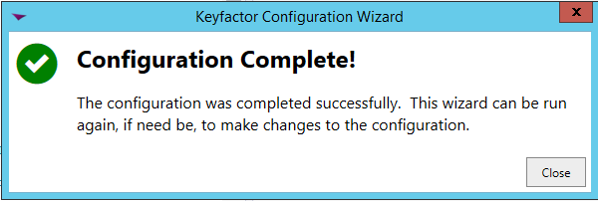

* If the Keyfactor Agent Configuration Wizard configured everything correctly, you should see the dialog above.

**3. Create an IIS With Binding Certificate Store within Keyfactor Command**

In Keyfactor Command create a new Certificate Store similar to the one below, selecting IIS With Binding as the Category and a Store Path with the format ***WebSiteName/IPAddress/PortNumber/HostName*** format (***HostName*** optional).

